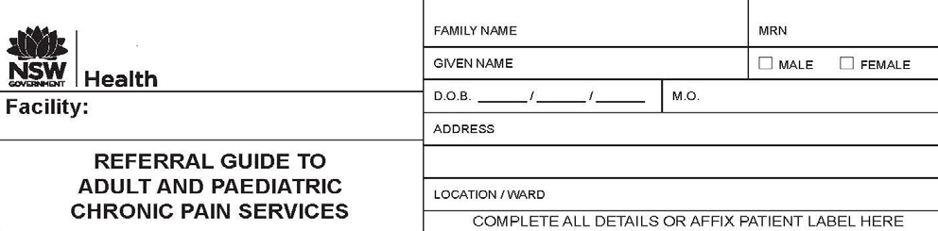

There are a number of publicly funded multi-disciplinary chronic pain services in NSW hospitals providing expert assessment, treatment and access to a range of self management based 'Pain Programmes'. The services are time-limited and require a referral from a medical practitioner with a provider number.

This is a guide to assist practitioners to establish suitability and to navigate the referral system. Once received, referrals will be assessed and prioritized by the Pain Service within your Local Health District, according to statewide criteria.

Indications for referral to a Pain Service:

Consider referral when the patient has chronic pain* and;
• all reasonable investigations have been completed;
• reasonable and accessible management in the primary care sector has been tried with insufficient success;
• pain has significant impact on some aspects of life - sleep, self care, mobility, work or school attendance, recreation, relationships and/or emotions.

Referrals are particularly encouraged when the patient has:
• exacerbations of chronic pain that resulted in Emergency Department presentations or hospital admissions.
• complex psychosocial influences on pain behaviour requiring specialised assessment and care
• current or past history of addiction or prescribed medication use that seem to be complicating current management e.g. escalating opioid requirement.
• difficult to control neuropathic pain
• difficult to control cancer pain

*Pain that is constant, and daily for a period of 3 months or more over the previous 6 months, or where the natural history of the painful condition predicts that this is likely to be the case.

The Pain Services will require:

• Completion of the attached referral form in full, where possible.

The preferences of the Chronic Pain Services are:

To work actively in partnership with the General Practitioner in ongoing management
• To work in close communication with other specialist services who are providing treatment for the same or related problem

Statewide Priority Categories

Priority 1 - Wait time 3-8 weeks
Pain interfering with sleep or self care, or requiring the assistance of another for activities of daily living; Children whose pain interferes with school attendance; Refractory cancer pain; Early neuropathic pain or complex regional pain syndrome (CRPS) <3months since onset.

Priority 2 - Wait time 2-6 months
Pain < 1 year not responding to GP management; frequent pain exacerbations occasioning Emergency Dept. presentations or hospital admissions, neuropathic pain, persistent pain following trauma or surgery, pain associated with marked physical interference or emotional distress, children and elderly

Priority 3 - Wait time 6-12 months
Pain > 1 year not responding to GP management, diagnostic advice, medication optimization, psychological distress, physical interference.

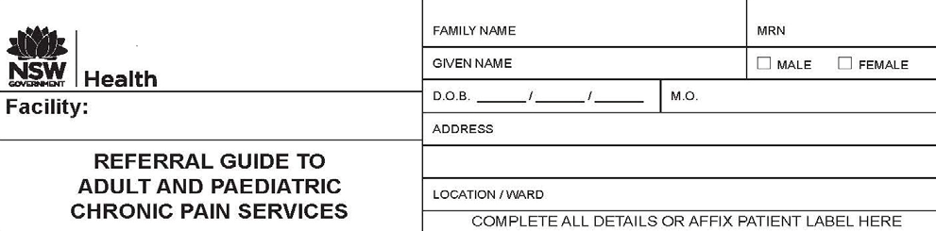
St Vincent’s Chronic Pain Service – St Vincent’s Hospital
Please complete all questions in this form and fax to: (02) 8382 3111 to enable appropriate triage. Incomplete forms cannot be processed. For further information you may contact us on: (02) 8382 1111.
Patient details
Family name: | Given Names:
Sex M □ F □ | Date of Birth: |  |  |  |  | Age >70 □ < 18 □
Address: |  |  |  |  |  | Postcode
Phone (H) | Phone (W) |  | Phone (M)
Indigenous/ CALD status Aboriginal and or Torres Strait  Islander Y  N  |  |  |  |  | CALD background  Y  N 
Country of Birth: | Preferred language: |  |  |  | Interpreter required  Y  N 
Medicare card no: |  | Medicare expiry date:
Referring Medical Officer’s details
Family Name: | Given Name:
Organisation/practice name: |  |  |  | Provider number:
Address: |  |  |  | Post code:
Phone: | Fax: |  |  | Email:
Nominated General Practitioner’s details
Should be identified if not referring medical officer
Family Name: | Given Name:
Organisation/practice name: |  |  |  | Provider number:
Address: |  |  |  | Postcode:
Phone: | Fax: |  |  | Email:
Will the patient require prior approval from an insurer to attend a clinic? Y  N 
Insurer Name: Claim Number:
Reason for referral - Please tick the relevant box (es)

Investigations pertaining to the pain complaint have been completed? 

Current Pain Management is ineffective? 

Pain has significant impact on sleep, self care or pain necessitating the assistance of 
others?

Pain has significant impact on mobility , work or school attendance, recreation, 
emotions?

Emergency Department presentations or hospital admissions? 

Complex psychosocial influences relating to pain requiring specialised care? 

History of addiction/prescribed medication use complicating current management 
e.g. escalating opioid requirement?

Difficult to control neuropathic pain? 

Difficult to control cancer pain? 

Persistent pain following trauma or surgery where there is concern regarding 
transition to chronic pain?

Location of pain.......................................................................................................... Impact of pain.............................................................................................................. Comments:
Priority category (See Referral Guide): 1  2  3 
Patient History
Relevant clinical history:
Background surgical and imaging history, please attach relevant reports.
Current treatment from other specialist or allied health service providers for the same  pain problem?  Aware and supportive of referral? Please provide details: | Y  N   Y  N 
History of assessment by another pain service or rehabilitation service for pain  management in the last 2 years? Name of service:  Please attach relevant correspondence. | Y  N 
Current medications (include dosage, route, frequency and include analgesics):
Allergies/adverse reactions: | Y  N 

Psychiatric history? Please describe: | Y  N 
Psychological stressors? Please describe: | Y  N 
Have any addiction services been involved?  Please provide details: | Y  N 
Could the patient have difficulty accessing information/services for the following: Impaired cognitive function?  Visual or hearing impairment?  Difficulty reading and or accessing forms? Difficulty travelling?  Comment: | Y  N  Y  N  Y  N  Y  N 
Has the patient consented to the referral? | Y  N 
Does the patient require an advocate/parent/guardian to be involved in consultations and management?  If yes, relationship to patient:  Name:  Contact details:  Has carer strain been identified? | Y  N   Y  N 
Would you like the relevant pain service to contact you for telephone advice as soon  as practical? | Y  N 
*Referral to parallel services such as addiction medicine, psychiatry and mental health may be essential.

Thank you for your time in completing this referral

GP Signature

With Acknowledgement to WentWest Ltd for production of template

