Jane is a 27 year old woman presenting for follow up after her antenatal bloods and dating scan. Antenatal screen was all normal except the urine result below.

UTIs In Pregnancy

Q/ Jane is asymptomatic. Is any treatment required?

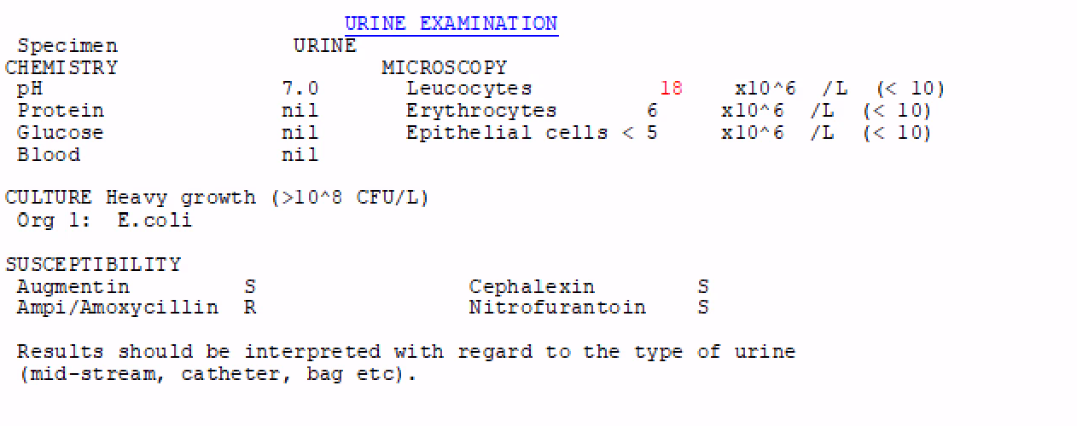

A/Yes – asymptomatic bactiuria should be treated in all pregnancies. More than 100,000 colony-forming units/mL (105 ) without symptoms of UTI, generally indicates asymptomatic bacteriuria. Due to physiological changes in the urinary tract during pregnancy, women are more likely to get recurrent infections and severe infections. The risk begins in week 6 and peaks during weeks 22 to 24. **Untreated bacteriuria in pregnancy is associated with a 20 to 30% increased risk of developing cystitis and pyelonephritis in later pregnancy.** Untreated bacteriuria may be associated with preterm birth, preeclampsia and low birth weight.

Practice Point – Routine midstream urine sample for all women at their first antenatal visit or not later than 16 weeks gestation.

Q/ What is the most common pathogen associated with asymptomatic bacteriuria?

A/The most common pathogen associated with asymptomatic bacteriuria in 70-80% of cases is E. Coli. Sensitivities should guide treatment. Examples of suitable regimens are the same as treating acute cystitis in pregnancy (see below).

Practice point - If group B streptococcus is detected in the urine at any stage of pregnancy, the patient will require prophylactic antibiotics during labour.

Jane comes back at 17 weeks pregnant. This time she has some lower pelvic pain, dysuria and urinary frequency. You suspect a UTI and send a urine culture and decide to start empiric treatment awaiting the urine sensitivities.

Q/ Which antibiotics are recommended for empirically for acute cystitis in pregnancy?

A/For empirical therapy of pregnant women with acute cystitis use:

1. **nitrofurantoin 100 mg orally, 6-hourly for 5 days**
   1. Avoid after 37 weeks' gestation, or sooner if early delivery is planned, due to increased risk of neonatal jaundice and haemolytic anaemia

**OR**

1. **cefalexin 500 mg orally, 12-hourly for 5 days.**
   1. Now second line due to increased antibiotic resistance

**CONSIDER**

1. **Trimethoprim 300mg daily for 3 days** 
   1. Only in second and third trimesters unless patient has been treated with trimethoprim in the previous 3 months

Modify empirical therapy once sensitives return. Suitable alternatives include:

1. Amoxicillin 500mg TDS for 5 days
2. Amoxicillin+clavulanate 500+125 mg orally, 12-hourly for 5 days (avoid close to birth due to risk of necrotising enterocolitis in neonates)

Practice point: Confirm the infection has resolved by repeating urine culture 1 to 2 weeks after treatment is completed.

Jane returns at 22 weeks again with the same symptoms. She now has recurrent UTIs and will require a MSU at each visit. This time however she develops systemic symptoms with chills, rigors, flank pain, nausea and vomiting and signs of dehydration. Fetal heart rate is elevated in your rooms at 180 bpm.

Q/ What do you advise when you see her at this stage

A/ Intravenous antibiotic treatment is recommended in all cases of acute pyelonephritis followed by oral antibiotics once afebrile for 24 hours for 10-14 days total.

Q/ At what point would you consider prophylactic antibiotics and which options?

A/Consider giving antibiotic prophylaxis after 2 or more separate episodes of acute cystitis or asymptomatic bacteriuria with risk factors for pyelonephritis (e.g. immune compromise, urinary tract anomalies, diabetes). Options include Cefalexin 250 mg or nitrofurantoin 50mg orally at night for the remainder of the pregnancy

**Reference: https://sydney.communityhealthpathways.org/28574.htm**