# To Snip or not to Snip!

Tongue ties (Ankyloglossia) have been a hot topic among parents in recent years, especially when it comes to concerns about feeding, speech and dental health.The Royal Hospital for Women (RHW) follow a structured approach to identify restrictive lingual frenulum’s that might be affecting breastfeeding. If needed, RHW perform a frenotomy to release the restriction and support a smoother breastfeeding experience.

Tongue-tie can affect breastfeeding by making it harder for a baby to latch and stay attached, leading to nipple pain, damage, poor sleep and slow weight gain. Limited tongue movement restricts milk removal, making range of motion a key factor in successful breastfeeding.

***Retrospective Clinical Audit of 200 women/baby dyads***

Over the past six years, RHW have gathered valuable insights into how treating restrictive lingual frenulums can impact breastfeeding. To better understand the benefits, RHW surveyed mothers before their procedure, then followed up at key points—day 1, and at 1, 3, and 6 months afterward. RHW looked at their comfort levels, how they were feeding their babies (breast or bottle), and whether they used nipple shields to help with latching. This data has helped shed light on the role of frenotomy in supporting breastfeeding success.

***Outcomes***

Most babies had their frenotomy done after the first week, which aligns with the RHW protocol. This approach gives the baby time to recover from birth, allows both mother and baby to get the hang of breastfeeding, and ensures the milk supply has started to establish. It’s all about creating the best conditions for a successful breastfeeding journey.

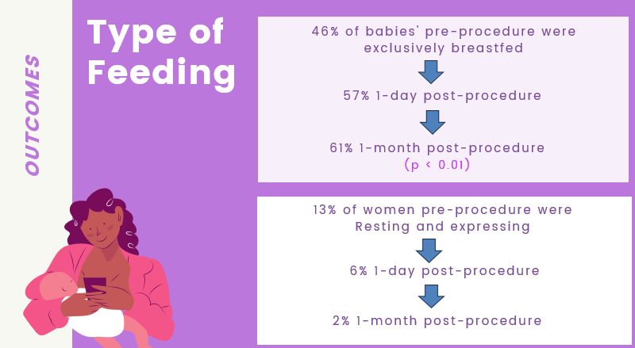

**Conclusion**

A frenotomy is a simple, minimally invasive procedure that can make a big difference for breastfeeding when a baby has a restrictive lingual frenulum. For mothers who are determined to continue breastfeeding, this procedure has been shown to significantly improve the breastfeeding experience, with most noticing positive changes within a month.

The benefits also seem to last—by six months, 51% of the babies were still exclusively breastfed and 74% were receiving some breastmilk. It’s a promising option for families looking to maintain their breastfeeding journey!

**Sarah McLean, Clinical Midwifery Consultant, Breastfeeding Support Unit**

**Royal Hospital for Women**

[**Sarah.McLean@health.nsw.gov.au**](mailto:Sarah.McLean@health.nsw.gov.au)

**9382 6370**