# RPA ANSC Newsletter: (06.06.2025)

**Long-term health risks following Hypertensive Disorders of Pregnancy**

Hypertensive disorders of pregnancy (HDP) include preeclampsia, gestational hypertension, and chronic hypertension and affect 5-10% of Australian pregnancies. As well as being a major cause of short-term maternal and fetal/neonatal illness, there is strong evidence that women after HDP have increased risk of chronic disease including cardiovascular disease, kidney disease and Type 2 diabetes [1-6].

Prior research has identified knowledge gaps regarding health after HDP. Furthermore, the recommended follow-up after HDP to promote optimal long-term health outcomes for women is not routinely implemented throughout practice [7, 8].

Pilot implementation research is now underway aimed at building capacity amongst healthcare providers to implement evidence-based care after HDP. Informed by prior research and co-designed with GPs and hospital healthcare providers [8, 9], targeted education and strategies to improve the handover-of-care between tertiary and primary care have been implemented across maternity services across Sydney Local Health District and South Eastern Sydney Local Health District.

At the Royal Prince Alfred Hospital, women who have experienced HDP will receive an HDP-specific discharge referral letter. This encourages women to see their GP regularly after their pregnancy. Follow-up recommendations with their GP is encouraged within 3 days from hospital discharge, and at 6 weeks and 6 months after birth unless otherwise indicated by their treating obstetrician or renal specialist. This letter will be sent to their registered GP via HealtheNet and includes:

* Guidance regarding evidence-based short and long-term follow-up for women
* Guidance for women and GPs to promote long-term health outcomes
* Links to evidence-based resources go guide future care

See below for an example of the post-HDP specific discharge letter and information for GPs.

GPs can also access the recently updated HDP *HealthPathway* for a quick and easy access to background, assessment, management and referral information for all women following HDP (Hypertensive Disorders of Pregnancy and Postpartum (HDP)): <https://sydney.communityhealthpathways.org/>).

Our teams are committed to providing high-quality evidence-based care through collaboration with women, GPs and other dedicated healthcare professionals.

If you have any questions regarding this initiative, please contact [jennifer.e.green-1@student.uts.edu.au](mailto:jennifer.e.green-1@student.uts.edu.au)

***Example post-HDP specific discharge letter and information for GPs***

[See attached]

**RPAH Post-HDP discharge letter**

Dear *Patient name*

*A copy of this letter has been provided to give to your GP*

Congratulations on the birth of your baby. You and your family may have many questions regarding your labour and birth and the implications on your future health or subsequent pregnancies. Please see your GP to discuss these in more detail.

As you will be aware, your pregnancy was complicated by a Hypertensive (high blood pressure) Disorder of Pregnancy (HDP).

At discharge, your prescribed medications are: *Insert here*

______________________________________

Unless otherwise instructed by the RPA renal/medical team, please follow-up with your GP as follows:

**GP follow-up care:**

1. If you are still taking blood pressure medications (antihypertensive therapy), please continue these as per instructions from the RPA renal/medical team.
2. **First week following hospital discharge:**
   1. Follow-up with your GP at 3 days of discharge for your blood pressure to be checked, and (if applicable) your antihypertensive therapy to be reviewed.
3. **6 weeks postnatal**:
   1. Follow-up with your GP for your routine 6 week postpartum assessment.
4. **6 months postnatal:**
   1. Follow-up with your GP at 6 months postpartum for a comprehensive health assessment including:
      1. BP check with additional 24hr ambulatory BP where possible
      2. BMI, waist circumference and metabolic profile
      3. Fasting bloods including cholesterol (LDL/HDL) and blood sugar level (BLG) (if OGTT has not already been performed for other reasons)
      4. Renal (UECs), Liver (LFTs), Haematological (FBCs)
      5. Urine protein and microalbumin to creatinine ratio assessment (uACR and/or uPCR)
   2. Discuss future health recommendations after HDP; including next pregnancy implications (if applicable).

This letter is to accompany the pregnancy, labour and birth hospital discharge summary provided to you by your maternity care provider. It is designed to outline the recommended follow-up care after your maternity discharge from *RPA Women and Babies* and provide you with some long-term health information.

Should you have any questions about the information contained in this letter please discuss this with your GP, obstetrician or midwife.

If your GP requires any further information or advice regarding this letter, they can contact RPA Kidney Centre on 9515 1700.

Yours sincerely

*Doctor/Midwife Name*

### **Where can I find support?**

**Speak to your GP**

This will assist you in addressing your pregnancy history and assist in making a long-term health plan.

**Resources**

There are some Australian-based organisations that may provide you with further information and support.

* **Future health after hypertensive disorders of pregnancy**
  + Top 10 Points for Women and Their Families from the SOMANZ Hypertension in Pregnancy Guidelines 2023
  + <https://www.somanz.org/content/uploads/2024/01/Top-10-Points-for-Women-and-Families-from-the-SOMANZ-HIPG-2023.pdf>
* **Healthy Diet recommendations:**
  + NSW Health Get Healthy Service (1300 806 258) <https://www.gethealthynsw.com.au/>
* **Smoking cessation** 
  + NSW Quitline (13 78 48 – 13QUIT)

<https://www.cancer.nsw.gov.au/prevention-and-screening/preventing-cancer/quit-smoking/nsw-quitline>

* + iCanQuit

<https://www.icanquit.com.au/>

* **Postnatal perinatal mental health support**
  + Centre of Perinatal Excellence

<https://www.cope.org.au/>

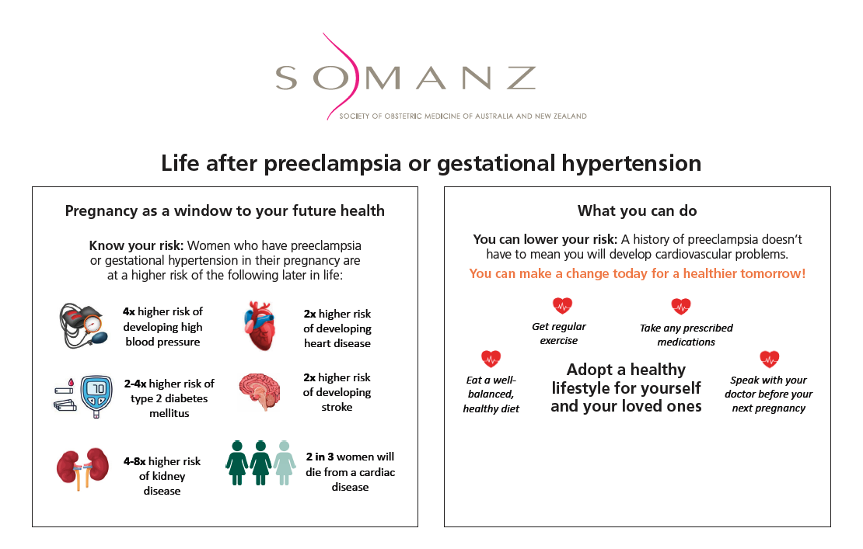

* <https://www.somanz.org/content/uploads/2024/01/Information-sheet-8.1-Life-after-preeclampsia.pdf>

**References:**

1. Ahmed, R., et al., *Pre-eclampsia and future cardiovascular risk among women: a review.* Journal of the American College of Cardiology, 2014. **63**(18): p. 1815-22.

2. Arnott, C., et al., *Maternal cardiovascular risk after hypertensive disorder of pregnancy.* Heart, 2020. **106**(24): p. 1927-1933.

3. Barrett, P.M., et al., *Hypertensive disorders of pregnancy and the risk of chronic kidney disease: A Swedish registry-based cohort study.* PLoS Medicine, 2020. **17**(8): p. e1003255.

4. Magee, L.A., et al., *The 2021 International Society for the Study of Hypertension in Pregnancy classification, diagnosis & management recommendations for international practice.* Pregnancy Hypertension: An International Journal of Women’s Cardiovascular Health, 2022. **27**: p. 148-169.

5. Shanmugalingam, R., et al., *A summary of the 2023 Society of Obstetric Medicine of Australia and New Zealand (SOMANZ) hypertension in pregnancy guideline.* Medical Journal of Australia, 2024. **220**(11): p. 582-591.

6. Timpka, S., et al., *Midlife development of type 2 diabetes and hypertension in women by history of hypertensive disorders of pregnancy.* Cardiovascular Diabetolgy, 2018. **17**(1): p. 124.

7. Roth, H., et al., *Assessing Knowledge Gaps of Women and Healthcare Providers Concerning Cardiovascular Risk After Hypertensive Disorders of Pregnancy-A Scoping Review.* Frontiers in Cardiovascular Medicine, 2019. **6**: p. 178.

8. Roth, H., et al., *Exploring education preferences of Australian women regarding long-term health after hypertensive disorders of pregnancy: a qualitative perspective.* BMC Women’s Health, 2021. **21**(1): p. 384.

9. Green, J.E., et al., *Exploring Australian knowledge and practice for maternal postnatal transition of care between hospital and primary care: A scoping review.* Women Birth, 2025. **38**(1): p. 101852.