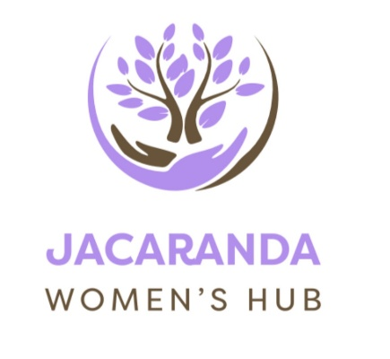
Jacaranda Women’s Hub
welcomes

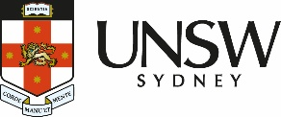
UNSW Tax and Business Advisory Clinic
Information session
Wednesday 10 December
1-2.30pm

Recognising Financial Abuse

Is someone restricting access to your bank accounts?
Have you been forced to take on someone’s debt?
Are they trying to control your spending?

You might be experiencing financial abuse.
Come along and hear from the friendly team from UNSW Tax and Business Advisory Clinic to learn how to recognise financial abuse and what you can do about it.

Please register to attend - info@jacarandawomenshub.org.au

21A Dalley Ave Pagewood info@jacarandawomenshub.org.au

