Importing Templates from the CESPHN Website

Instruction on how to download Best Practice and Medical Director templates from CESPHN website and import them into Best Practice or Medical Director.

Download Templates from the CESPHN Website

Go to the Templates section of the website <https://cesphn.org.au/general-practice/practice-support-and-development/templates> and expand the Download Templates section.

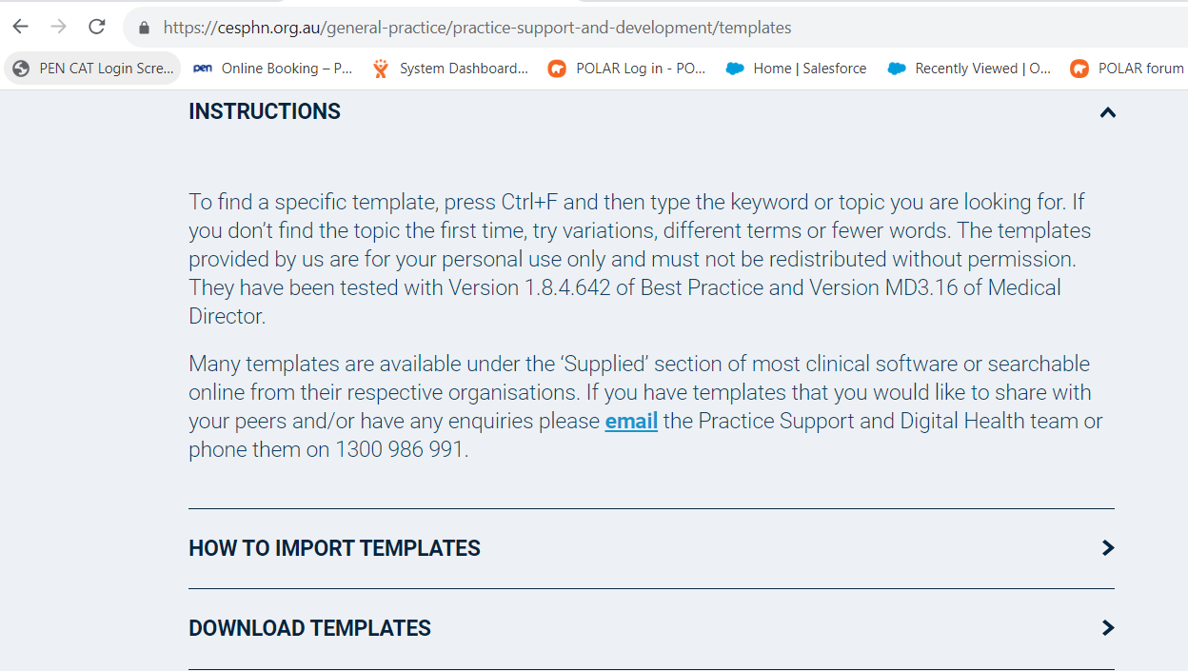

Select the template you wish to download, right click and select ***Save link as***…

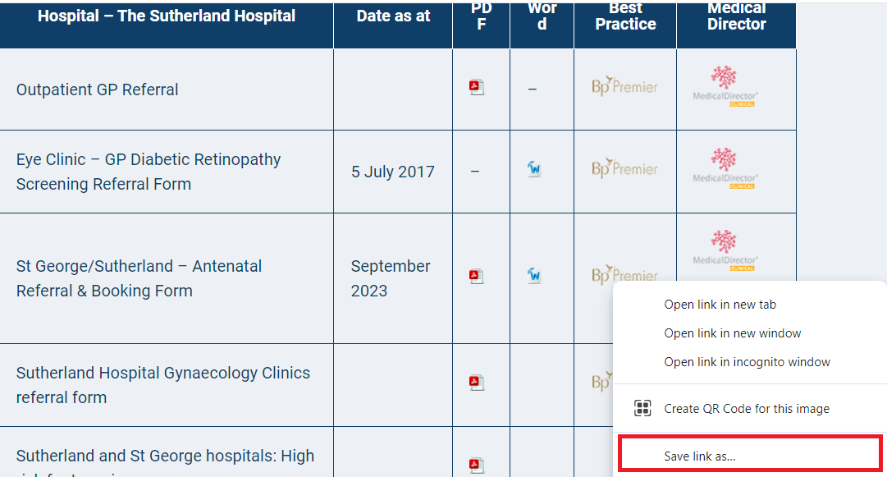

Save the template into designated destination, ie Documents etc. **DO NOT OPEN** the template as this would corrupt the template fields.

To import into Best Practice and Medical Director follow the instructions on the following pages.

Importing Templates – Best Practice

Open the Word Processor.

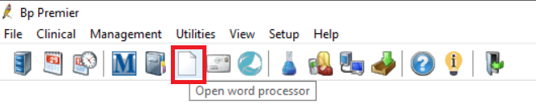.

Select Templates – Import Template

Navigate to the folder where you saved the template, select template and Open.

Once the template is imported select File – Save as template – Save. NB You can change the template name before saving. Make sure to select Available to all users.

The template has been imported into Word Processor.

Importing Templates – Medical Director

Open the Letter Writer.

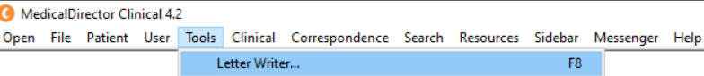

Select File – New – Blank Template

Select OK to open. Select File – Import Template - OK

Once the template is imported select File – Save as template – Save. NB You can change the template name before saving. Make sure to select Available to all users.

The template has been imported into Word Processor.