Practice Name:
PIP QI quarter: please tick ü | Quarter 1  Nov – Jan ☐ | Quarter 2  Feb – Apr ☒ | Quarter 3  May – Jul ☐ | Quarter 4  Aug – Oct ☐
Date: 10/3/2026

Name of QIA | Increase the proportion of active patients with complete and up-to-date Social and Family History recorded in their health summary.

PLAN
Goal   | <What are we trying to accomplish and when? Make the goal simple, measurable, achievable, realistic and timely>  Increase the percentage of active patients with recorded Social and Family History from the current baseline to ≥75 % by 30/06/2026.
Baseline Data: | <What is our current data saying?>  According to CESPHN Practice Progress Report from 1/3/26  Social History - 52%,  Family History is at 48%
Data to be Collected: | <What data will we use to track our improvement?>  We will run POLAR QIPC report > Clinical> Data Quality every 2 weeks to check % of RACGP active patients with Social & Family History recorded and to confirm that our change ideas are working.

Steps for Implementation
What |  | Who | By When

Organise a training session to demonstrate correct data entry in Clinical Software (no free text in Progress Notes)

Trial post it notes in consult rooms as a prompt to update opportunistically e.g. during GPCCMP, Health Assessment

Put on the agenda for next Clinical Meeting – team-based discussion to gain insight into current workflows and barriers

Improve New Patient Registration Form and trial for 1 month

Reception to review completed patient forms and gently prompt when Social and Family History not provided

Download Walrus – point of care prompt tool (part of our Polar licence)

DO – Insert any observations you had during implementation of this plan unforeseen amendments, unexpected events

- What actions were carried out (step-by-step if needed)
- Who was involved
- Any deviations from the original plan

STUDY Reflections, knowledge gained, effectiveness of improvement

Examples:
- Describe barriers such as time constraints during consultations and incomplete patient forms and how you addressed them
- patients are reluctant to provide the information – we will consider a poster in the waiting room explaining why we ask these questions
- improving new patient form does not result in immediate improvement because the patients don’t have the RACGP Active status yet

ACT - Next steps? Record the details of your option under the relevant heading below
ADOPT - record what you will do next to support making this change business as usual

ADAPT - record your changes and re-test with another PDSA cycle

ABANDON - record which change idea you will test next and start a new PDSA.

Evidence of improvement. <Screenshots from extraction tool, Practice Progress Report>

Baseline as at 1/3/26
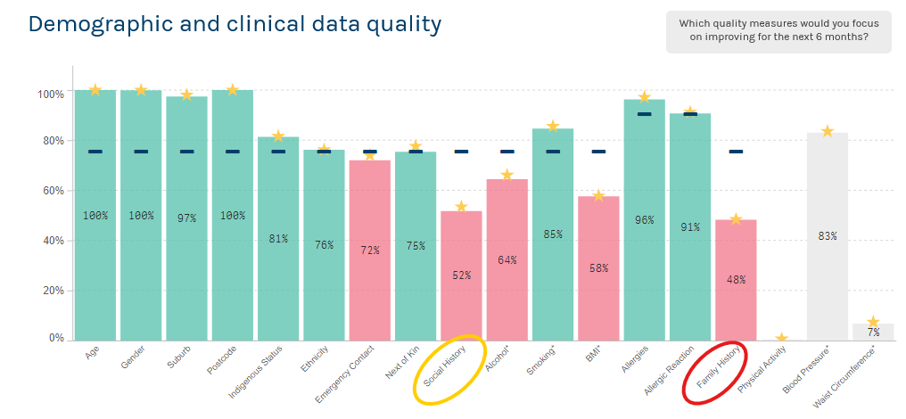

Progress 1/4/2026

Progress 1/5/2026

Data Entry in Best Practice
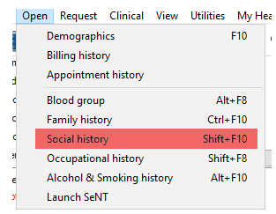
If any one of the below items are recorded, the Social History quality indicator will be set as 'Recorded'.
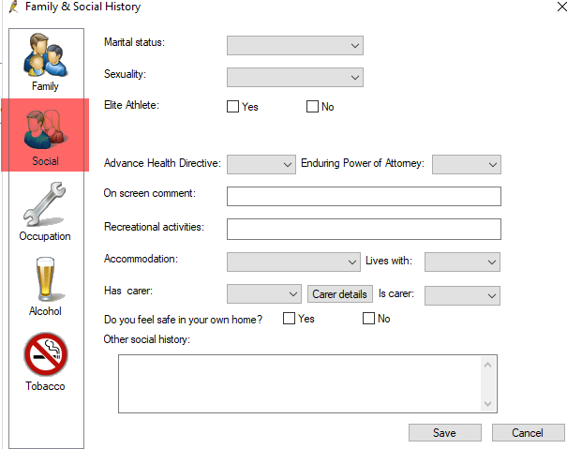
- Marital status
- Sexuality
- Elite sports person
- Recreation (recorded as a pass if any information is stored for the patient, data not extracted by POLAR)
- Accommodation
- Lives with
- Has carer
- Other social history (recorded as a pass if any information is stored for the patient, no details leave the practice)
- Advanced Care Directive
- Enduring power of attorney

If any one of the below items are recorded, the Family History quality indicator will be set as 'Recorded'.
- Unknown (e.g. adopted)
- No significant family history
- Mother alive
- Father alive
- Other comment (recorded as a pass if any information is stored for the patient, no details leave the practice)

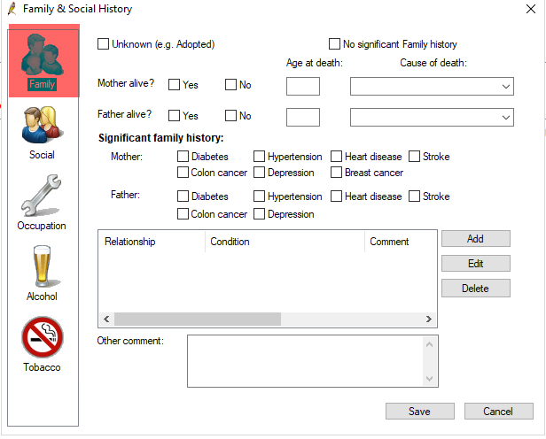

Data Entry in Medical Director
Recorded as a pass if there is information recorded in the Family History comment box (content not extracted by POLAR)
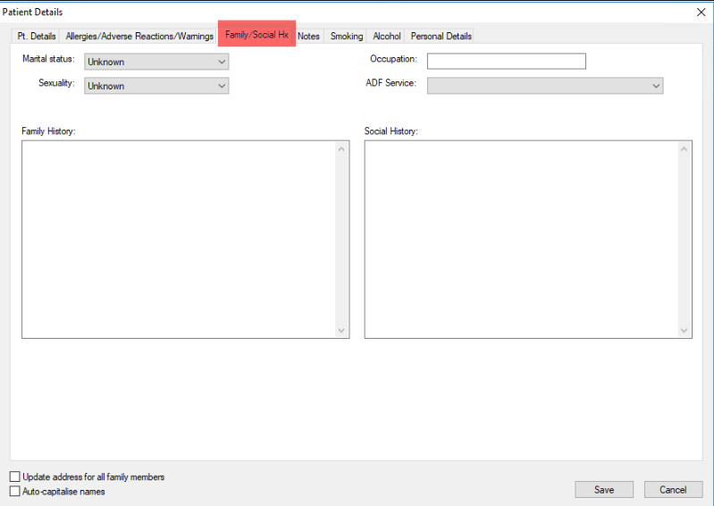

If any one of the below are recorded, the Social History quality indicator will be set as 'Recorded'.
The items are:
- Marital status
- Occupation (recorded as a pass if any information is stored for the patient, data not extracted by POLAR)
- Sexuality
- ADF service
- Social history comment box (recorded as a pass if any information is stored for the patient, data not extracted by POLAR)

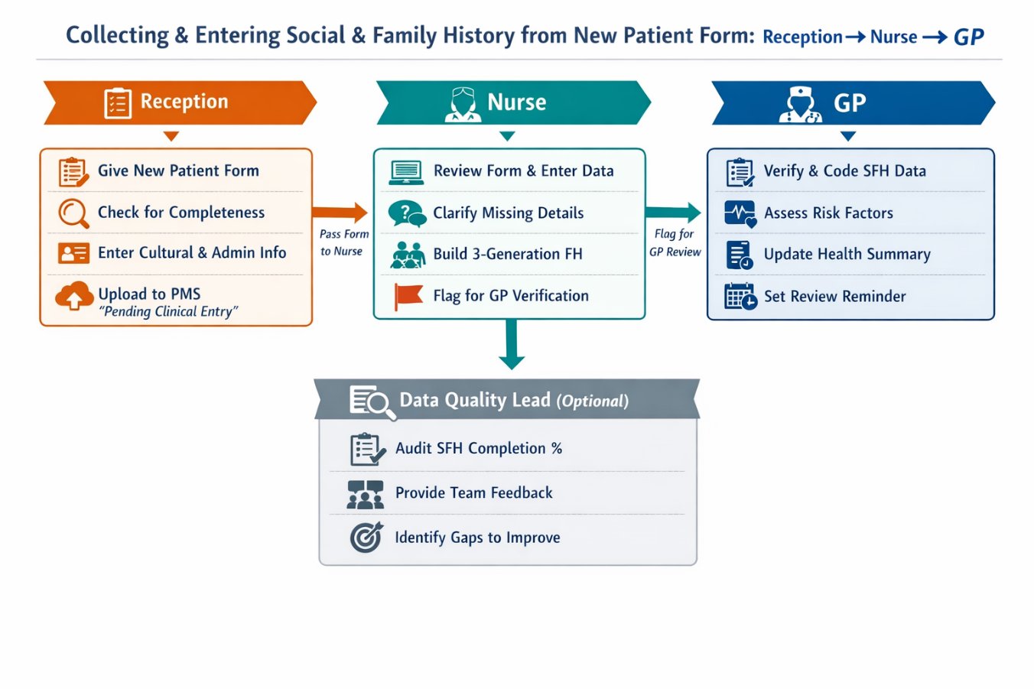
💬 GP Consultation Script (Short)
“Before we continue, I’d like to update your family and social history. This helps us assess risks and tailor your care. Has anyone in your immediate family had conditions like heart disease, diabetes, or cancer? And can you tell me about your lifestyle, cultural background, and support at home?”
(Use structured Best Practice fields to enter responses.)

💬 Admin Script
“Before your appointment, would you mind completing these fields in New Patient Form (Social & Family History form?) It helps the doctor provide better care. It should only take 2–3 minutes.”

💬 Nurse Script
“I’ll run through your family history today. We ask about these conditions because they can help us identify risks early.” (Review questionnaire/new patient form and enter data into structured fields.)

