Practice Name:
PIP QI quarter:  please tick ü | Quarter 1  Nov – Jan ☐ | Quarter 2  Feb – Apr ☒ | Quarter 3  May – Jul ☐ | Quarter 4  Aug – Oct ☐
Date: _________
Name of QIA: | Increase the uptake of Health Assessments among Aboriginal and Torres Strait Islander People.

PLAN
Goal   | <What are we trying to accomplish and when? Make the goal simple, measurable, achievable, realistic and timely>  We will complete 15 MBS Item 715 Health Assessments for eligible Aboriginal and Torres Strait Islander patients by DD/MM/YYYY
Baseline Data: | <What is our current data saying?>  xx patients eligible for MBS Item 715 Health Assessments completed as per CESPHN MBS Opportunity Report from (dd/mm/yyyy)
Data to be collected: | <What data will we use to track our improvement?>  To measure the improvements, we will use POLAR QIPC report > Tracked MBS> Indigenous Health Assessment  • The number of patients who are eligible for a 715 Health Assessment initially and,  • The number of patients who have a 715 health assessment completed.

Steps for Implementation
What |  | Who | By When
1. Research MBS Item 715 Health Assessments and develop a process within the clinical team of how to undertake the assessment.  CESPHN Aboriginal Health Resources |  | GP/Nurse
2. Utilise patient resources to promote MBS Item 715 Health Assessments in our waiting room and on our social media.  (example: Deadly Choices Shirts on page 5) |  | PM /Receptionist
3. Identify patients eligible for MBS Item 715 Health Assessments by creating a report in POLAR and checking HPOS to identify if assessment has been completed elsewhere (see how to guide here) |  | Nurse/PM
4. Set up a recall system |  | PM/Receptionist

DO – Insert any observations you had during implementation of this plan
<Did you do it? Insert any observations you had during implementation of this plan, unforeseen amendments, unexpected events>
Example:

Mid-February: A baseline health assessment report was generated using the practice’s data extraction tool to identify eligible Aboriginal and Torres Strait Islander patients who had not had a 715 Health Assessment in the previous 12 months.

Following week: The eligibility list was cross-checked against Medicare/HPOS records to ensure patients had not completed a health assessment elsewhere.

Late February: Eligible patients were contacted via SMS and/or phone calls inviting them to book a 715 Health Assessment.

Early March: The first health assessments were completed. During one assessment, additional chronic disease risk factors were identified, and appropriate referrals were arranged. This demonstrated the benefit of structured preventive screening and prompted the team to streamline referral processes during assessments.

Mid-March: A progress report was re-run to monitor uptake. A small increase in completed health assessments was noted, which reassured the team that the recall strategy was effective.

Early April: A GP identified an eligible patient opportunistically during a routine consultation and encouraged booking a 715 assessment. This reinforced the importance of opportunistic offers in addition to recall systems.

Late April: A follow-up report showed steady progress, including patients who had been contacted and those identified opportunistically.

May: Continued monitoring demonstrated a noticeable increase in completed assessments. Positive feedback was shared with the team to maintain engagement and motivation.

June: Unforeseen staff illness and leave resulted in some appointments being rescheduled, temporarily slowing progress. Data extraction for that month was delayed.

July: Reporting resumed, and a modest increase in completed health assessments was observed, consistent with the reduced clinical capacity during the previous period.

August: Final review of the reporting cycle showed a sustained increase in total completed 715 Health Assessments compared to baseline. The recall system and opportunistic offering were both contributing to improved uptake.

STUDY Reflections, knowledge gained, effectiveness of improvement

<Reflections: knowledge gained, effectiveness of improvement, measurement goals, potential changes that could be made in the next cycle>

The test worked well and achieved a great result. We anticipated that we would complete 15 health assessments and we ended up completing a total of 17 health assessments which surpassed our expectations.

Some GPs in our practice have expressed interest in learning more about the Integrated Team Care (ITC) program for Aboriginal and Torres Strait Islander people, including its components of care coordination, supplementary services, and outreach support. We have invited CESPHN to deliver an education session for the entire practice team to build understanding and support implementation.

ACT - Next steps? Record the details of your option under the relevant heading
<Next steps? Record the details of your option under the relevant heading below >
ADOPT - record what you will do next to support making this change business as usual

Partner with CESPHN for Care Coordination
- Engage with Central and Eastern Sydney Primary Health Network to:
  - Link patients identified through 715 assessments to care coordination programs
  - Support patients with complex or chronic conditions
  - Improve access to allied health, mental health, and social support services
- Establish referral pathways from 715 assessments directly into CESPHN-supported programs
ADAPT - record your changes and re-test with another PDSA cycle

ABANDON - record which change idea you will test next and start a new PDSA.

Evidence of improvement.
<Screenshots from extraction tool, Practice Progress Report>

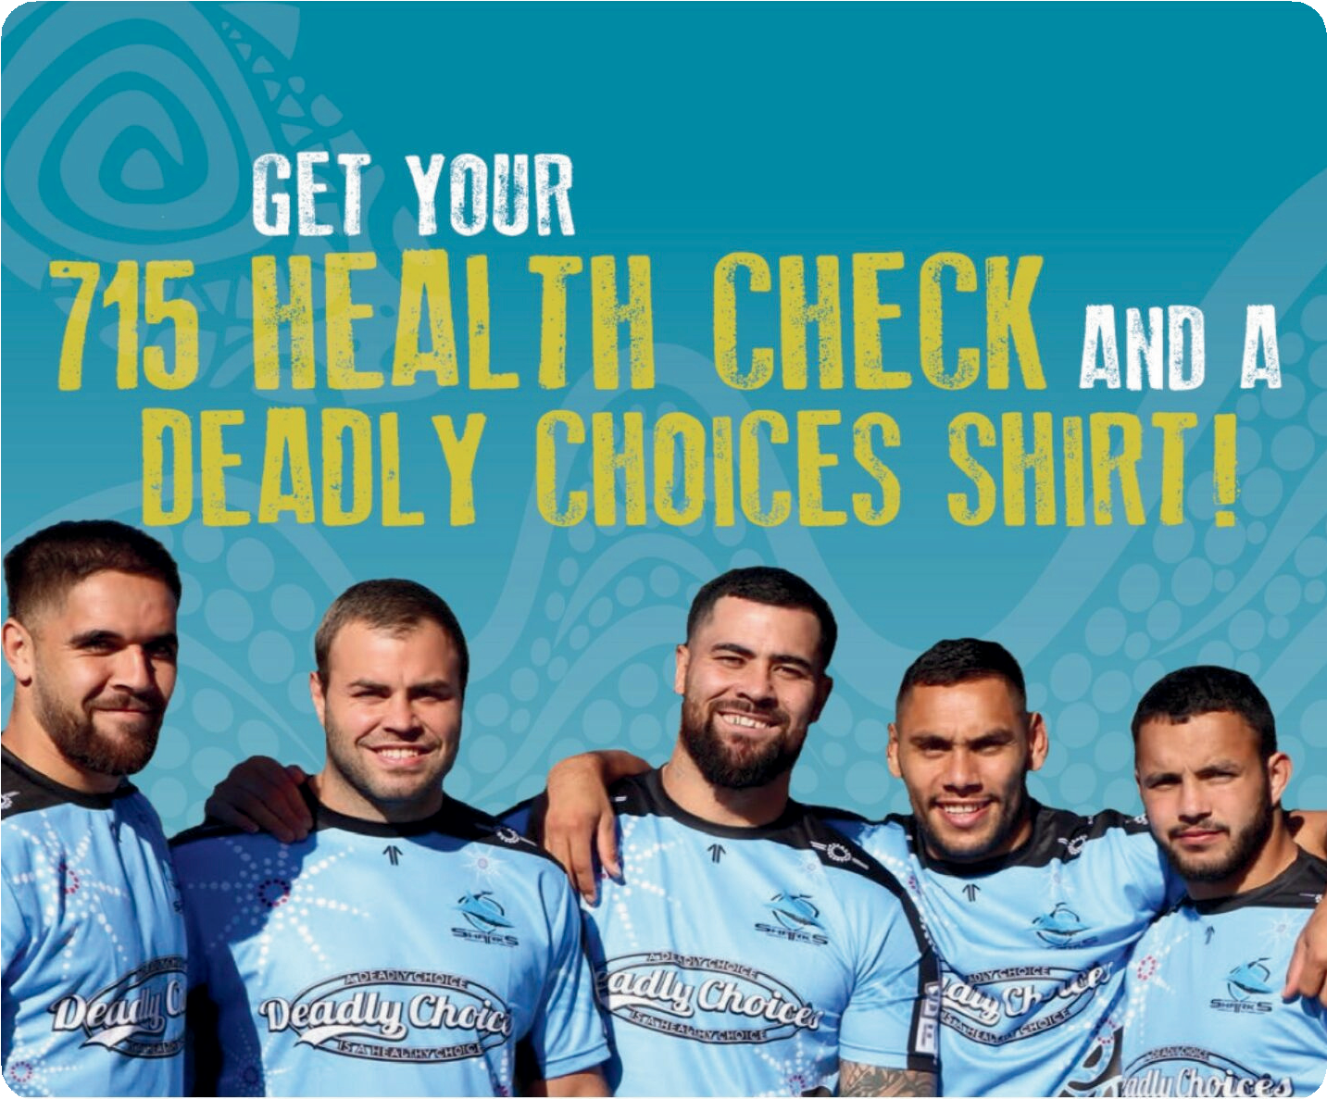
The Deadly Choices program through the Cronulla Sharks are holding a promotion for Aboriginal and Torres Strait Islander Clients in the CESPHN region.
Clients who have had a 715 health check in the past 6 months may be eligible for Deadly Choices shirt from the teams below:
- Cronulla Sharks
- South Sydney Rabbitohs
- NSW Deadly Blues
- Sydney Roosters
- Indigenous All Stars
Bring this flyer to your local GP and ask for a 715 Health Assessment.
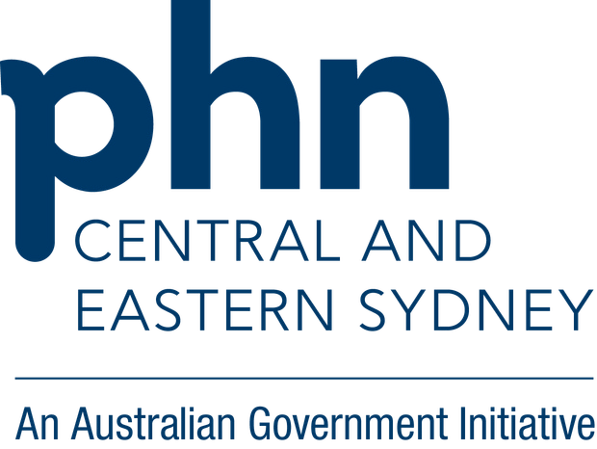
Once completed, ask your GP to fill out the back of this form, email it to aboriginalhealth@cesphn.com.au, and your jersey
will be posted to you.

DEADLY CHOICES HEALTH CHECK CONFIRMATION FORM

When you complete your health check at your trusted GP, please have them fill out this
form and return to either your Deadly Choices Program Officer, or, Central and Eastern
Sydney PHN.
Please note this is only available to clients in the Central Eastern Sydney Primary Health
Network region.

This form certifies that (full name) __________________________________________
visited (practice name) ________________________________ on the (date)________
and received a 715 Health Check.

Stamp of AICCHS/GP
Name of Doctor: …………………………………………………………….
Address of Practice: ………………………………………………………….
…………………………………………………………………………………………
…………………………………………………………………………………………
…………………………………………………………………………………………
I confirm that the MBS 715 Aboriginal and Torres Strait Islander health Assessment
has been completed for this patient,
Signature of health provider: ________________________________________________
Date: ___________

Shirt Preference: Shirt size: …………………
☐ Cronulla Sharks ☐ South Sydney Rabbitohs ☐ Sydney Roosters
☐ NSW Blues ☐ Indigenous All Stars
Patient’s Postal Address: ………………………………………………………………………………………………………….
…………………………………………………………………………………………………………
Phone number: ………………………
WHEN COMPLETED PLEASE RETURN FORM TO: aboriginalhealth@cesphn.com.au

