Tailorable
Ideas Form

This tailorable Easy Read ideas form is for health service staff to use with people with intellectual disability and their supporters. It is an accessible way for the person to reflect on the health service and provide feedback.



How to use this Tailorable Easy Read Ideas Form

- It is important to make sure the person understands what this form says. Ask the person if they read Easy Read. Find out if they need support to read Easy Read. If they do, make sure you send the letter in time for them to show a support person.
- Insert relevant text where prompted. Text placeholders and instructions are marked in between brackets and in orange. E.g. [insert text here].
- When you have finished tailoring the letter, change all font to black. Do this by selecting the table cells and choose font colour – black.
- Finally, remove the table lines. Do this by selecting the table cells then go to table design and select no border.
- Follow these principles when tailoring and formatting the letter to ensure it is Easy Read:
  - Nothing smaller than 14 point. Size 14 for main text and 16 or larger for headings.
  - Use Arial, Verdana or Tahoma (sans serif fonts).
  - Ensure plenty of white space. Include no more than four images per page.
  - Less is best, keep it simple:
    - Use short sentences and simple everyday words.
    - Avoid jargon and slang. If needing to use technical terms use bold and explain what the terms mean.
    - Avoid unnecessary details, focus on what people need to know, not what it is nice to know.

Note: All the images included in this document have been purchased through stock sites and Photosymbols and cannot be reproduced, redistributed or used for any other purpose without their permission. You need to ask CID if you want to use any of the pictures. Contact CID at health@cid.org.
Funded by the Department of Social Services.

Easy Read Ideas Form
 | You can help us make [name of service] better.  We want to hear your ideas.
         | For this part you can tick the box that is right for you.  Would you tell other people to come to [name of service]?  - Yes  - No  - Unsure
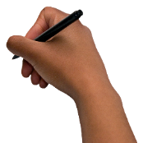   | For this part you can write your answer.  It is OK if you need support to write your answer.  What did you like about [name of service]?  How can we make [name of service] better?
 | If you did not get good health care.  You can make a complaint.  A complaint means speaking up when you are not happy.
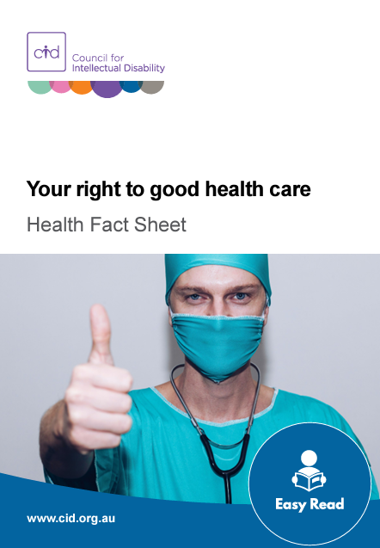 | There is a fact sheet called Your right to good health care for tips on making complaints.  You can see the factsheet here:  www.cid.org.au/your-right-to-good-health-care-fact-sheet/
 | Thank you for your ideas.

